# **ASSIGNMENTS ON DIGITAL MARKETING**

NAME : SANGEETHA A

DEPARTMENT : B.E COMPUTER SCIENCE AND ENGINEERING

COLLEGE : 8151 DHANALAKSHMI SRINIVASAN INSTITUTE OF TECHNOLOGY

NAANMUDHALVAN COURSE : DIGITAL MARKETING

NM ID : 6D850C53039AB73AD2544FA5A024F04

**ASSIGNMENT 1**

Create a blog or website using blogspot and word press customize

The theme design and post new article with 500 words.

<https://happycone.blogspot.com/2023/08/happy-cones.html>

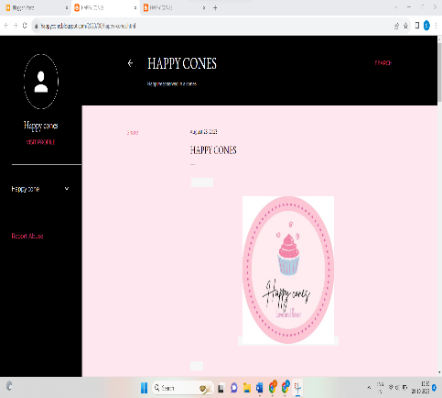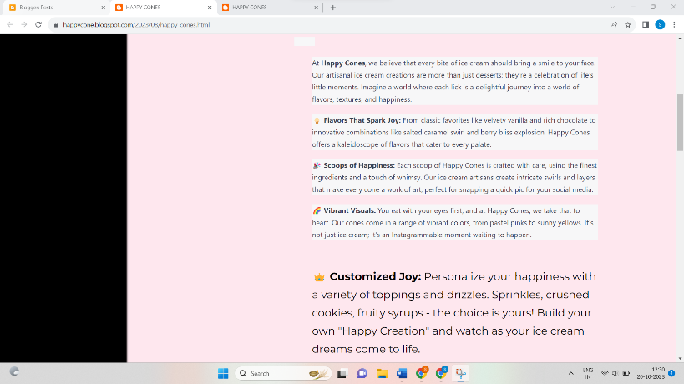

**ASSIGNMENT 2:**

Create a new Facebook business pages and post one social media poster for your brand.

<https://www.facebook.com/Happycones12?mibextid=ZbWKwL>

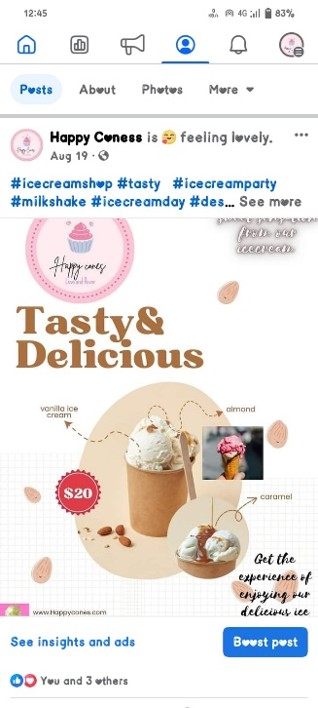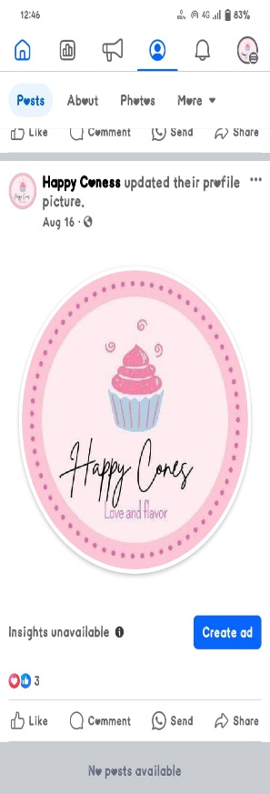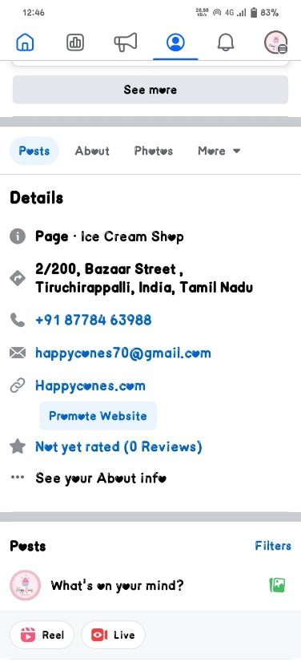

**ASSIGNMENT 3:**

Create and design a social media advertisement poster using Canva.

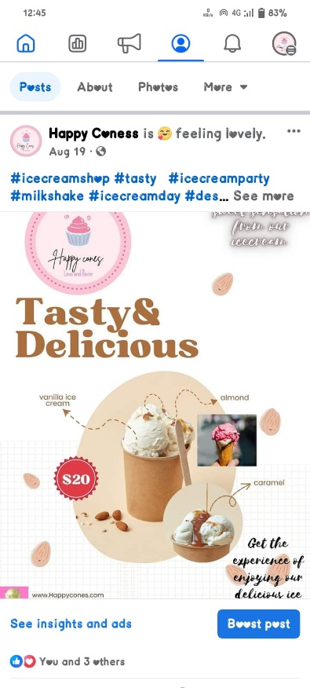

**ASSIGNMENT 4:**

Create Email newsletter design using Mailchimp or Canva tool.

<https://happycone.blogspot.com/2023/08/email-newsletter-happy-cones.html>

